**Group L:** Ella Wulforst, Leah Norton, Avi Popat, Ashwin Rajkumar

A01- Tasks, Pains & Gains

1. **Task**

* As a college student/recent graduate living in a large city, I must ride a bike as transportation in the winter

1. **Pains**

- Riding a bike in cold weather is uncomfortable and can cause me to get sick

- I cannot ride my bike in the rain or when there is a lot of snow

- I have to walk or use public transportation instead during winter (takes more time to walk and public transportation costs money)

- It is difficult to ride a bike bundled up in winter clothes

**c. Gains**

- Easy and accessible transportation at any time of the year

- Eliminate environmental impact generated by use of other modes of transportation

- I do not need to worry about the parking/storage/payment of a car

**d. Appendix**

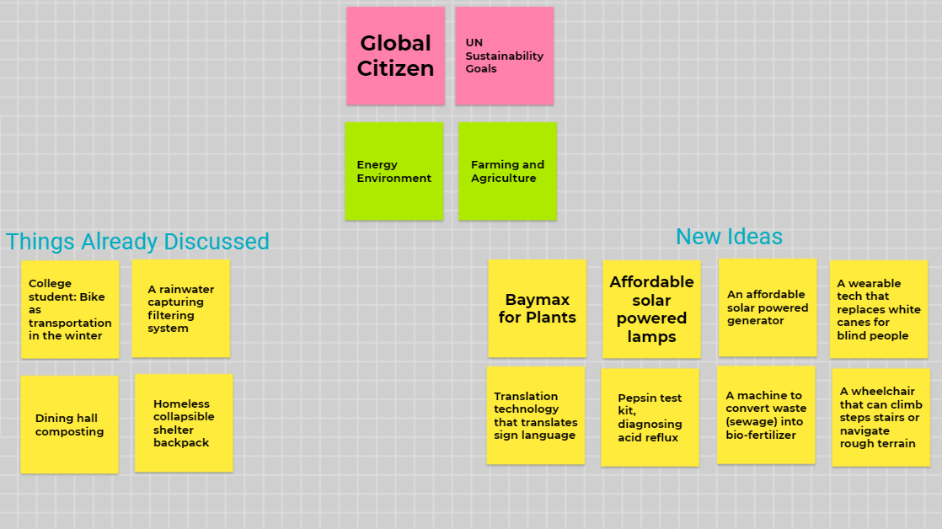

| **Project Manager for Assignment** | | | |
| --- | --- | --- | --- |
| Ella Wulforst | | | |
| **Deputy Manager for Assignment** | | | |
| Leah Norton | | | |
| **Drafted Assignment** | **Reviewed Assignment** | **Revised Assignment** | **Proofread Assignment** |
| Ella Wulforst | Leah Norton | Ashwin Rajkumar | Avi Popat |
| **Created Figures** | | **Created Tables** | |
| Ashwin Rajkumar | | Avi Popat | |
| **Other Contributions** | | | |
| N/A | | | |
| **Problems Overcome** | | | |
| N/A | | | |